DS Essentials

Script Visuals Duration Editing
180-320 words 10-25 pictures 1.5- 2.5 minutes DV PAL Widescreen
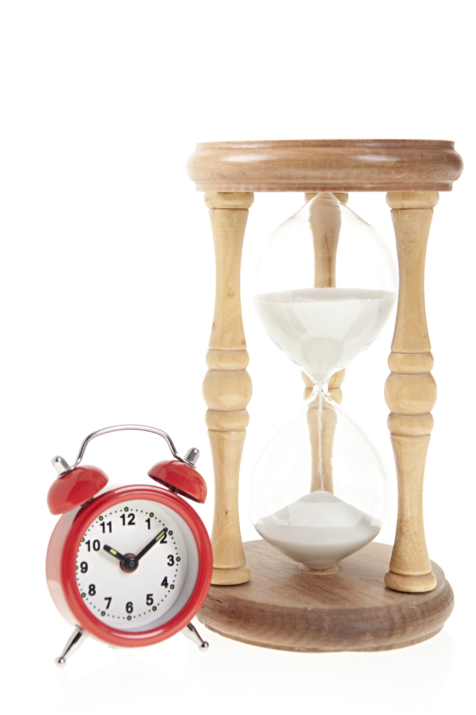
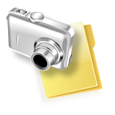


1280 pixels X 720 pixels

300 d.p.i

JPEG orTiff

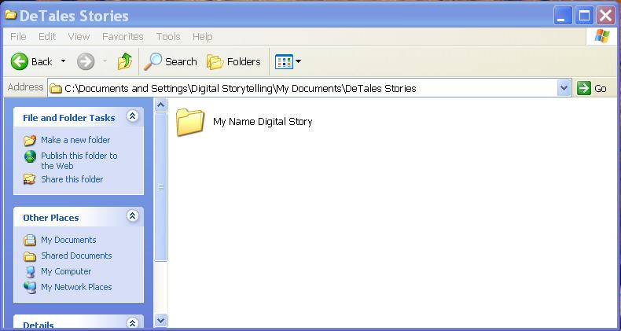
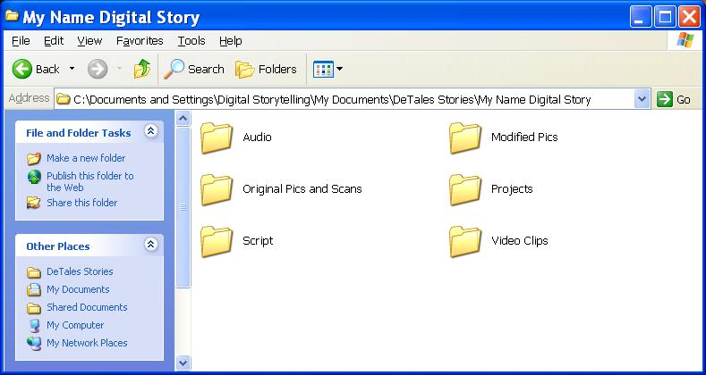
Create a master folder with your name on. Create these 6 folders in your master folder

